ROMAN CATHOLIC DIOCESE OF NOTTINGHAM

HOLY NAME OF JESUS PARISH, SOUTH LEICESTERSHIRE

Parish Priest: Fr. Joel Nwalozie - email: office@holynameofjesussouthleics.uk Tel: 0116 2863676
Deadline for Newsletter items – noon on Wednesdays via email
Safeguarding Representatives:
Narborough – Mike Newton – email Michael.newtonpsr@dioceseofnottingham.uk Mobile 07513 725361
Lutterworth – Heather Freeman – email heatherfreemanPSR@dioceseofnottingham.uk Mobile 07753 562298

NEWSLETTER 31 OCTOBER – 1 November 2026
31st SUNDAY IN ORDINARY TIME

FOR ALL DECEASED: Please pray for those who have died recently and for those whose anniversaries occur about this time and for all the souls in Purgatory who have no one to pray for them. May they rest in eternal peace and rise in glory.

SICK AND HOUSEBOUND: If you know of anyone who would like to receive Confession and Holy Communion, please let Fr. Joel know and he will be happy to visit them, and anoint them at home.

LECTIO DIVINA: The next meeting is scheduled for Friday 30th October at Narborough. It will commence with Mass at 2.00pm followed by Scripture Readings. Please note the Group has reverted to meeting in the afternoons until further notice. Anyone wishing to join will be made very welcome.

SECOND COLLECTION FOR MISSIO: Next weekend 7/8th November. Fr Emmanuel Nuh is coming to preach the mission appeal. Please be generous as usual. Thanks.

SOLEMNITY OF ALL SAINTS: The saints are a reflection of the Son of God, who live on earth according to the beatitudes practiced by Jesus Christ even before he taught them: poverty, gentleness, pureness of heart, love for peace, persecution, martyrdom… It is impossible to determine the number of saints (144,000 is a symbolic number to indicate a huge immensity), and they are from all races and nations (First Reading). As they are a reflection of the Son on earth, the fullness of filial happiness in the vision of God is awaiting them in Heaven (Second Reading) (THE DICASTERY ARCHIVES, 1999).

OCTOBER IS THE MONTH OF THE HOLY ROSARY: Praying the Rosary can bring peace and help us slow down, especially during busy or difficult days. Even when we are distracted or don’t know what to say, the Rosary gives us a way to continue praying and entrusting our lives to God. Ultimately, the Rosary is not about simply repeating words, it is about sending time with God, contemplating Jesus, and allowing prayer to gradually transform our daily lives. Why not make that extra effort, in the final week of October to arrive in time for the Rosary on the days it is recited before Masses in our Parishes. It is only an extra 20 minutes out of your day! You will find details containing all Masses / Liturgical Activities on the separate sheet.

NOVEMBER IS THE MONTH OF THE HOLY SOULS: This is an opportunity when we make a list of our deceased Family & Friends whom we would like to be included in all Masses celebrated throughout the month. Pious List envelopes are available in the Porch. When you have completed your list, put it into the envelope, and if you wish, enclose a donation to the church, and place the envelope into the box on the Altar steps.Please Note - There will be Mass at Lutterworth at 12 noon on Monday 2nd November

MASS INTENTIONS: Envelopes are available in the Porch for you to complete. Please be mindful that a Mass may not be possible on the date you request, but it will be celebrated as soon as is practicable.

LITTLE CHURCH AT LUTTERWORTH – Are taking a break. Back again on 1st November.

REFRESHMENTS AFTER 9.30am MASS ON SUNDAYS, NARBOROUGH: Everyone is welcome. Please come and join us in the Hall.
REFRESHMENTS AFTER MASSES, LUTTERWORTH: on Thursdays and Sundays. Everyone is welcome to join us in the Hall.
SCRABBLE AT LUTTERWORTH: Every Tuesday. 2.00pm – 4.00pm. Contact Jo for details on 07471 032396

SVP/FOOD BANK: Please leave donated food at the back of the Church at St. Pius X. Thank you for your support.

LUTTERWORTH FOODBANK: The next Foodbank collection will be 3rd November.

LIFE CHARITY, NARBOROUGH: Please donate articles of clothing, bric-a-brac, toys, electrical goods and household items at the back of the church. Thank you for your support. If you have items to donate, at Lutterworth, please let us know and arrangements can be made for their collection.

PARISH YOUTH CLUB: Arrangements are being finalized to commence with our Parish Youth Club in November. The aim of the Club is to be both a Spiritual and Social Endeavour. In the meantime, please help by informing our young people of this development. Exact details will be provided shortly.

NARBOROUGH CHURCH CLEANING: Due to the age and other commitments of some of our volunteers we are now desperately short of people to clean the church. This is usually done by 2 people and takes approximately one hour every 6 weeks or so. If you feel you could spare an hour to help keep the church clean and tidy please give your name to Father Joel.

LUTTERWORTH BINGO: Final week to check your Raffle Tickets. A list has been posted on Church Noticeboards for checking. Please let us know if you have a winning ticket and we will get your prize to you. Any unclaimed prizes will be donated to the Bazaar at Narborough on the 21st November.
SEAFARERS CHRISTMAS SHOEBOXES 2026: Alan Wilson and Trevor Curry will collect Christmas Shoeboxes for the Stella Maris Mission for Seafarers at Immingham. There is a flyer inside each (empty) shoebox to let you know what to include. Collections will be taking place across the parish of ‘Holy Name of Jesus’ Parish, covering Narborough and Lutterworth. As all boxes have now been taken at Lutterworth and if you still wish to provide one, please let Nora know and she will contact Alan, or Trevor to bring some more. Knitted hats are also very much wanted should any knitters have spare wool and wondering what to do with it! When you have filled your box, add a Greetings card, and wrap it in Festive Paper. You are respectfully asked to place your box ON THE BOTTOM ALTAR STEP ONLY please in the Lady Chapel at Lutterworth – to prevent any danger of falling, as these steps are quite shallow and can be deceptive! If you only want to donate a few items, please leave them in the box provided in the Porch and they will be made up into full boxes before being dispatched. Please donate all products by 30th November for delivery early in December. Anything received after this date will have ‘missed the boat’! Thank You.
SOCIETY for the PROTECTION of the UNBORN CHILD (SPUC): Eileen Fox is the Lutterworth Church Representative for SPUC. We would like to have a Representative from Narborough also. Eileen is willing to help with any questions you may have regarding their activities. She will explain fully what the role entails and it would be greatly appreciated if we could have a Representative in each of our churches, under the Parish of Holy Name of Jesus. Membership of the Society can be arranged by a Representative for any Parishioners. Membership cards are issued to those people who sign up, as the Society does not receive any Government help and relies solely on donations from the Public to fund their activities. Publications, brochures, pamphlets etc are provided from time to time containing further information. SPUC hold a White Flower collection once a year to support their initiatives. Please seriously consider lending your support as a Representative, by speaking to Eileen at Lutterworth, 07988 605763 or via email to wildeileenfox@yahoo.co.uk

PARISH BAZAAR: Holy Name of Jesus South Leicestershire Parish bazaar will be held at St Pius X Narborough on Saturday 21st November 2026, 10.00am – 12.30pm. This is one of our major fundraisers for the Parish and we would like your help with raffle prizes, bottles for the bottle stall, chocolate for the chocolate tombola. Any re-gifted gifts you may be able to provide us with. All donations can be left at either Church and would be very much appreciated. A box has been provided in the Porch at Lutterworth for you to place items in for the Bazaar which will be taken to St. Pius ahead of the date. To all cake makers in the Parish, we will also be looking (on the Friday or Saturday of the 20th and 21st) for any cakes, scones etc that you can provide for us to sell.

Bishop Patrick will celebrate Mass for all the Deceased Clergy and Religious of our Diocese, especially those who have died over the past year, on the feast of the Dedication of the Lateran Basilica, Monday 9th November at 1.00pm in our Cathedral. Parishioners are also encouraged to attend. Canon Malachy and his team at the Cathedral will be making the usual arrangements for a light lunch in Cathedral Hall after the Mass; please let Fr. Simon Gilespie know that you are intending to attend the Mass and stay for the lunch afterwards. Fr Simon Gillespie 07760 372105 simon.gillespie@dioceseofnottingham.uk
CAFOD: Love your neighbour and share the joy of Christmas with a CAFOD World Gift, from safe water to school supplies! A meaningful way to bless loved ones while putting your faith into action in solidarity with families around the world. Collect a catalogue from church, call 0300 777 0030 or visit www.worldgifts.cafod.org.uk.


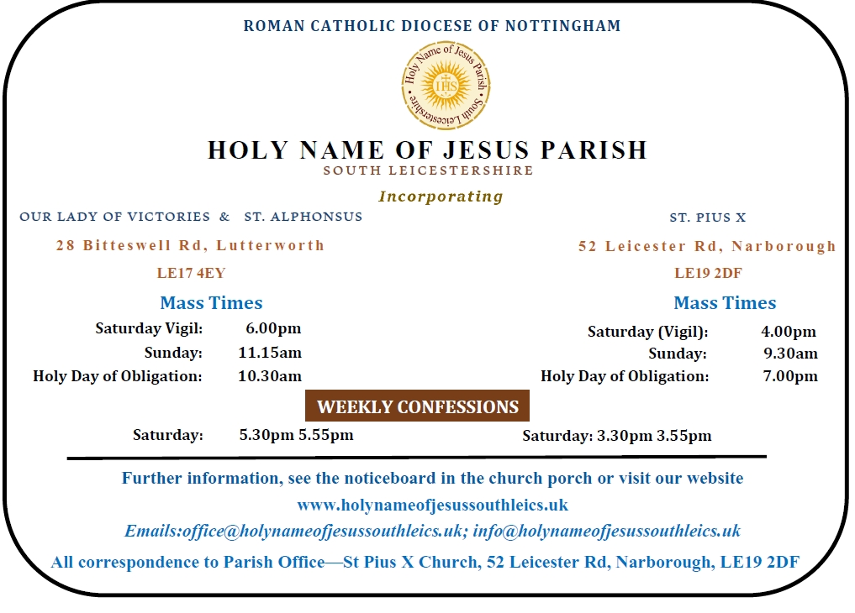
Tel: 0116 2863676
WEEKEND & WEEKDAY MASSES
31 OCTOBER – 1 November 2026
The Angelus is recited before all Masses
Our Lady of Victories & St. Alphonsus, Lutterworth
Mass Times Holy Souls remembered in all Masses during Nov. Mass Intentions
Sat | 31st Oct | 6.00pm |  | Rosary 5.30pm | Hugh Williamson (Welfare)
Sun | 1st Nov | 11.15am |  | Rosary 10.45am | Damian Shearer (Welfare)
Mon | 2nd Nov | 12.00 noon | All Souls Day |  | All Souls
Tues | 3rd Nov | 10.30am | Adoration 9.30am |  | All Souls  Shane Reynolds (Birthday)
Thurs | 5th Nov | 10.30am |  |  | Marion & Kevin Smyth (RIP)
Sat | 7th Nov | 6.00pm |  | Rosary 5.30pm | All Souls  Damian & Family (Welfare)
Sun | 8th Nov | 11.15am |  | Rosary 10.45am | All Souls  Fr. Thomas Delaney RIP Birthday remembrance

Lutterworth: Tues. 9.30 – 10.30 EUCHARISTIC ADORATION & ROSARY

------------------------------------ o 0 o ---------------------------------

St. Pius X, Narborough
Mass Times Holy Souls remembered in all Masses during Nov. Mass Intentions
Sat | 31st Oct | 4.00pm |  | Rosary 3.30pm | For a Special Intention
Sun | 1st Nov | 9.30am | All Saints Day | Rosary 9.00am
Mon | 2nd Nov | 10.00am | Adoration 9.00am | Rosary 9.30am | All Souls
Sat | 7th Nov | 4.00pm |  | Rosary 3.30pm | Kathleen & Francis Henderson (RIP)
Sun | 8th Nov | 9.30am |  | Rosary 9.00am

Narborough: Monday 9.00am – 10am EUCHARISTIC ADORATION & ROSARY

